
Burpham Preschool - Registration Form

Child Details
First Name: Middle Name(s): Surname:
Date of Birth: | Male / Female
Age at Entry: Years Months |  | Position in Family
Religion: |  | Languages Spoken at home:
Parent/Carer/Guardian Details
Parent/Carer/Guardian 1
Full Name:
Date of Birth: NI Number: (needed to register children on funding portal)
Relationship to Child: Legal Parental Responsibility? YES / NO
Address:
Home Tel:
Mobile: Work:
Email address:

Parent/Carer/Guardian 2
Full Name:
Date of Birth: NI Number: (needed to register children on funding portal)
Relationship to Child: Legal Parental Responsibility? YES / NO
Address:
Home Tel:
Mobile: Work:
Email address:

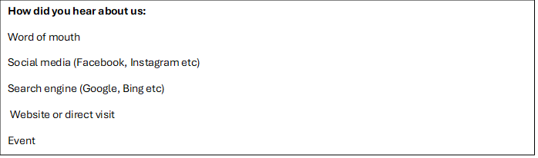

Parent/Carer name: ______________________________________________________
Signature: _______________________________________________________________
Date: ___________________________
Does your child have any additional educational needs or disabilities (AND)? Please give details.


Session Request – Burpham Preschool

Child's Name: ____________________________________DoB: ___________
Preferred start date: __________________________ (If new starter) Term: Summer (Sept) 25 / Autumn (Jan) 25 / Spring 26

*Universal 15 hrs - Funded sessions for 3-4yrs
or
*Funded 15 hours - FEET or Working Parent Sessions

Check your eligibility for FEET and either 15 or 30 hours Working Parent funding at:
Homepage | Childcare Choices - https://www.childcarechoices.gov.uk/

Please select which funding you will be using: Universal : FEET : Working Parent

 | Monday | Tuesday | Wednesday | Thursday | Friday
9am–1pm (total 4 hrs)
9am - 3pm (total 6 hrs)

If you would like to extend your 15 hours to 16 or 18 hours for a 1pm or 3pm finish on one of your days, please see *3 & **4 in the Self-Payment table over the page.

*Additional Sessions:
for 2-3-4yr olds eligible for 30 hours Working Parent Entitlement

 | Monday | Tuesday | Wednesday | Thursday | Friday
9am–1pm (total 4 hrs)
9am - 3pm (total 6 hrs)

Please provide your FEET, 15 or 30 hours Working Parent code:

**Please see overleaf for Self-payment options and further information...
*Self-payment Sessions:
And additional days/sessions beyond 15 hours FEET & 15 hours Universal or Working Parent funding
Self-payment Sessions | Monday | Tuesday | Wednesday | Thursday | Friday
9am–1pm (total 4 hrs)
9am - 3pm (total 6 hrs)
12pm - 1pm (1 additional hour)
12pm - 3pm (3 additional hours)

Self-payment session Times & Rates | 2 Years | 3-4 Years
1: 9am–1pm (total 4 hrs) | £36.00 | £32.00
2: 9am - 3pm (total 6 hrs) | £54.00 | £48.00
*3: 12pm - 1pm  1 x additional hour to extend 15 hours to 16 hours to have 4 x 9am - 1pm sessions) *NOT available as a standalone session* | £9.00 | £8.00
**4: 12pm - 3pm  3 additional hours to extend 15 hours to 18 hours to have 3 x 9am - 3pm sessions) **NOT available as a standalone session* | £27.00 | £24.00

Please Note:
- To help children settle into preschool and form a secure, trusting and positive rapport with the staff and other children, children must attend for a minimum number of three 9am-1pm sessions (12 hours) per week.
- We do not offer refunds for any sessions not attended, i.e. for sickness or holiday etc.
- Self-payment sessions will be invoiced through our ‘eyworks’ online admin management system and are to be paid within two weeks of receipt of invoice.
- Swapping sessions/days and ‘ad hoc’ additional sessions can be requested and will be permitted at the managers discretion, and availability for these will be based on numbers booked to be attending for the sessions requested. All additional sessions will need to be paid for at the current session rate.

Parent's Name: ________________________________________
Parent's signature: __________________________________Date: ______________________

